COMPARATIVE STUDY OF OLIGOTROPHIC BACTERIAL SPECIES CULTIVATED FROM JACK BRADLEY CAVE, KENTUCKY.

Adin Pemberton, Jennifer Millette and Hazel A. Barton*.

Department of Biological Sciences, Northern Kentucky University,
Highland Heights, KY 41099, USA

*Corresponding author: bartonh@nku.edu and www.cavescience.com

ABSTRACT

Due to geologic isolation and the absence of sunlight energy, the majority of caves represent a starved environment in which microscopic life subsists by scavenging available nutrients. In order to compare the relative diversity of cultivable bacterial species between organic-rich and organic-limited cave conditions, samples were collected from Jack Bradley Cave, Kentucky. Bacteria were taken from a dry passage with no apparent surface input (oligotrophic) and from a lower stream passage with a surface stream inflow (copiotrophic). In order to increase the types and numbers of bacteria that could be cultivated, various media ranging from Luria Bertani to distilled water plates were used. Multiple bacteria species were successfully cultivated, with a greater diversity of colonies being observed on the nutrient deficient plates, indicating that the microorganisms in this environment are adapted to low nutrient conditions. Unique colonies were purified through colony isolation, generating a culture collection of 501 cultivars. In order to identify unique species, genomic DNA was isolated and PCR was used to amplify the 16S rDNA sequence. The species were grouped into 110 unique cultivars using restriction fragment length polymorphism of the 16S rDNA sequence. These species were established using DNA sequencing, BLAST and phylogenetic alignment. The results demonstrate that many of the cultivars identified from these cave environments represent previously undescribed species, belonging to Pseudomonads, Caulobacter, and Actinomycetes. However, these species do not represent major populations in the communities identified in cave environments using non-cultivation techniques. We were able to isolate “non-traditional” organisms from this environment on nutrient limited plates, often only in association with other species. Our results suggest that traditional cultivation techniques from starved environments favor species that demonstrate metabolic flexibility, while oligotrophic organisms may be identified as metabolically adaptable “consortia.”

INTRODUCTION

We began our studies with a simple question shared by many other microbiologists: what are the chemical limits of life? To answer this question, we wanted to determine the lower limits of nutrient availability able to support microbial community subsistence in extremely starved terrestrial ecosystems. Caves, with limited exception, form through the erosional processes of water. By the time caves are enlarged sufficiently to allow human access, the water has (generally) departed, leaving the cave exposed to an oxygenated atmosphere (15). Without sunlight energy, the entry of nutrients into the system becomes a function of the geology and depth of the cave; significant organic input is limited to the entrance zone and areas fed by surface water, whether percolating through the bedrock or entering the system through faults (15). Due to this geologic isolation, the majority of caves therefore represent an essentially oxidized and starved environment in which microscopic life subsists by scavenging available nutrients.

Unlike other starved environments where one might wish to study oligotrophic survival, caves (with training) are easily accessible and contain a stable environment where diurnal and seasonal variations do not cause substantial physical variations in the system (15). Literature on oligotrophic cave communities is sparse, with studies being carried out in caves of the United States, Spain and Italy (6, 8, 13, 14, 19). However, many of these investigations relied on standard cultivation techniques, while it has been estimated that <1% of microorganisms present in any environment are culturable (2). Due to the sensitivity to the oxidative and osmotic stressors found in cultivation media and a slow growth rate, it is likely that the percentage of unculturable species is significantly higher in the case of oligotrophic organisms living in these starved cave systems (10, 16-18, 20).

Through previous non-cultivation, molecular phylogenetic-based studies in oligotrophic cave environments, we have observed a surprising diversity in the number of species identified (3). This is in contrast to the accepted ecological literature, wherein environments with a limiting energy source should also have limited species diversity through competitive exclusion (5). Contrary to this, Gottschal argues that competitive exclusion only applies to communities where one nutrient is limiting and that in the context of oligotrophic microbial communities, the diverse metabolic activity of different species results in continual nutrient flux and limitation, in which numerous factors effect competition and subsequent diversity (11). In order to answer the question of species diversity and metabolic activity within the oligotrophs living in cave systems, it is important to directly assess the metabolic properties of microorganisms living in these environments. Such data provide measurable metabolic activities, rather than those presumed through phylogenetic comparison (1). Unfortunately there are significant difficulties with the cultivation of oligotrophs, with the assumption that the rate-limiting step in bacterial growth is simply nutrient availability, and not the inherent growth rate of the cell itself (16). We therefore carried out a comparative cultivation study to identify the type of bacterial species that could be cultivated on media with differing levels of carbon and energy, supplements and antioxidants. The ability of individual bacterial species to be cultivated from cave environments with differing amounts of energy entering the system was also compared, to determine whether the oligotrophic nature of the cave does indeed play a role in the level species diversity.

MATERIALS AND METHODS

Our study was carried out in Jack Bradley Cave, Kentucky, an approximately 1,600 m cave system formed within the Mississippian age St. Genevieve limestone of southern Kentucky. Two passages were identified for sampling within the cave, both of which were approximately 30 m below the surface. One area, considered oligotrophic, was in an upper-level paleo-cave with limited surface input, other than rare flooding events or water percolating into the system. The other location, considered copiotrophic, receives nutrient input from a surface stream entering the cave system. Other than the amount of surface nutrient input, the physical conditions of these two locations were constant (approximately 14°C, >90% humidity).

To test the culturability of organisms from this environment, we developed a series of low-nutrient plates (Table 1). In the cave, the plates were inoculated by swabbing a ~ 5 cm³ area of the wall. The swab is then rinsed in 1 ml of sterile water, used as the stock to swab all the plates; this results in each plate being inoculated from the same source, ensuring the observable growth patterns reflect the growth characteristics on the media, rather than a bias introduced by the area of the wall examined. All the plates are then incubated under aphotic conditions with approximately 50% humidity at 20°C.

Table 1. Cultivation Media Used Within Jack Bradley Cave.

Agar Mediaª | Acronym
Distilled Water | DW
Soil extract | S
Soil extract plus glycerol | SG
Soil extract plus pyruvate | SP
Soil extract plus calcium carbonate powder | SC
Soil extract plus calcium carbonate and Dulbecco’s mineral supplement | SCM
Soil extract plus calcium carbonate and Dulbecco’s vitamin supplement | SCV
Soil extract plus calcium carbonate, Dulbecco’s vitamin and mineral supplement | SCMV
Soil extract plus calcium carbonate, Dulbecco’s vitamin and mineral supplement, and pyruvate | SCMVP
Luria Bertani | LB
ª Media is listed in ascending nutrient status, with distilled water being the most starved and LB the richest.

Once a number of colonies were grown on the plates, colonies showing unique morphology were streaked onto fresh media and purified using single colony technique (Figure 1). These cultivars were identified using small subunit (16S) ribosomal RNA (SSU-rDNA) linear sequencing. Briefly, individual colonies were picked into 50 μl PCR buffer with 0.1% NP-40 detergent and subjected to boiling lysis at 95˚C for 5 minutes. The supernatant was then used as a template in a PCR reaction using the bacterial specific 8F primer and universal 1525R primer (primer sequences at www.cavescience.com). The 16S sequence was amplified in reaction mixtures containing (final concentrations) 1 M Betaine, 1 X PCR buffer, 2.5 mM MgCl₂, 200 μM of each dNTP, 300 nM of each forward and reverse primer, and 0.025 U of AmpliTaq Gold (Perkin Elmer) per μl. Reaction mixtures were incubated on a Mastercycle Gradient thermal cycler (Eppendorf Scientific) at 94˚C for 12 min for initial denaturation and activation of the AmpliTaq Gold. PCR was then carried out for 30 cycles at 94˚C for 1 min, 64˚C for 45 s, and 72˚C for 1 min 30 s, with a final extension period of 8 min at 72˚C.

In order to identify unique species, all PCR products were screen by restriction fragment length polymorphism (RFLP). Briefly, 20 μl of crude rDNA product was then digested with 1.5 U of the 4-base-specific restriction endonucleases HindPI1 and MspI in 1X NEB buffer 2 (New England Biolabs), in a final volume of 25 μl for 2 hours at 37˚C. Digested fragments were separated by electrophoresis on a 2% SeaKem LE agarose gel (FMC BioProducts) and visualized by ethidium bromide staining and UV illumination. Unique RFLP patterns were grouped visually and unique species were selected for sequencing using linear sequencing. This protocol involved an initial 8F/1525R PCR reaction of the unknown species. The PCR product was then purified using a Qiagen PCR clean-up kit, to remove unincorporated primers and template DNA. This DNA fragment was then used as a template for sequencing on a Long ReadIR 4200 DNA sequencer (Li-Cor, Inc.), using the Thermo Sequenase Cycle Sequencing Kit (USB Corp.) and a
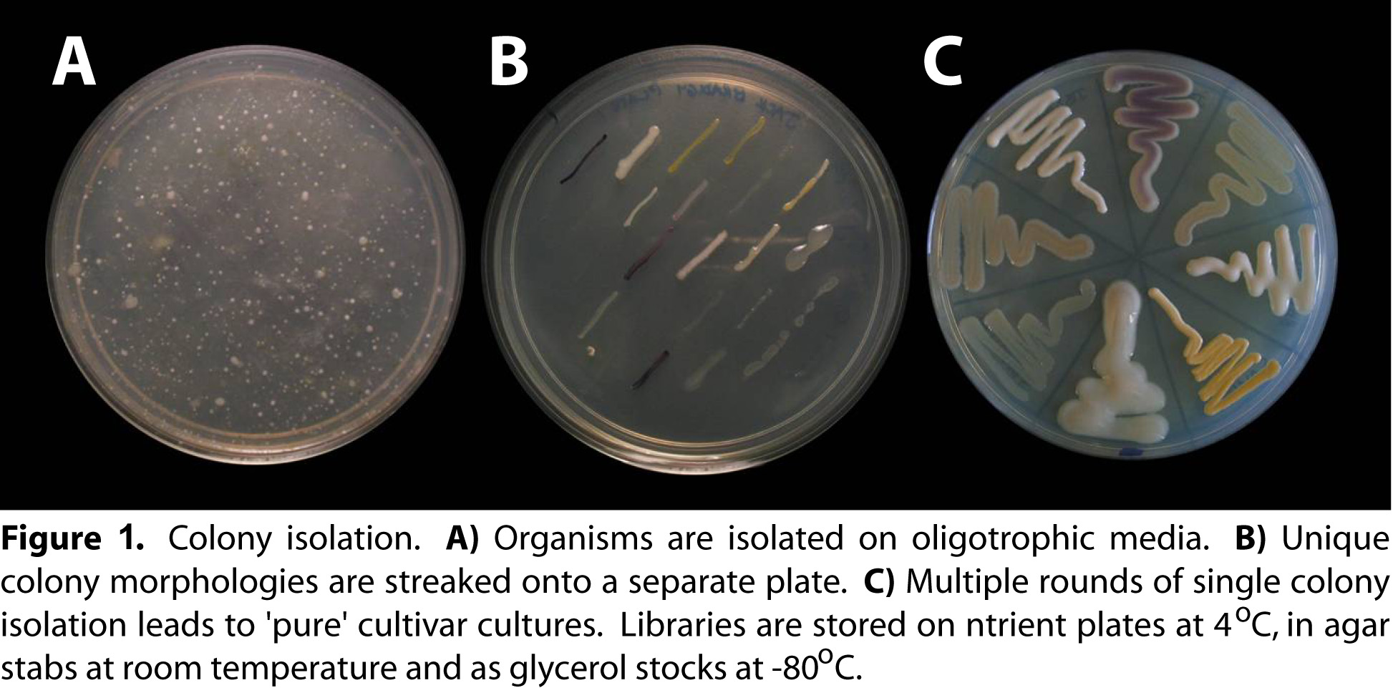

labeled 515F primer and unlabelled 1100R primer, in accordance with the manufacturer’s linear sequencing
instructions. Sequences that were problematic through G+C rich areas were sequenced using the Epicenter high GC sequencing kit, again following the manufacturers recommended protocol (Epicenter). Primers for sequencing allowed sufficient coverage to sequence the ~600 base insert of the bacterial rDNAs in both directions. Sequences were speciated by comparison to cultivated representatives by use of the BLAST (Basic Local Alignment Search Tool) network service (http://www.ncbi.nlm.nih.gov/BLAST).

RESULTS

On average, following inoculation, colonies were observed on the nutrient media within one day to two weeks. The time for the colonies to appear on the plates roughly corresponded with the nutrient state of the media, with colonies appearing much more quickly on nutrient rich plates, such as LB media, when compared with oligotrophic media such as DW. Once a number of unique colony morphologies were observed on the plates, these were streaked onto identical media for single colony isolation. Due to the length of time required for some colonies to grow, the length of time for single colony isolation occurred anywhere from one week to six months. Beyond that time, it was considered that species could not be isolated in pure culture and represented syntrophic relationships between species, as represented by cultivars such as JBSV2A4. Following colony isolation, a total of 501 different cultivars were identified, which were subsequently grouped into 111 unique RFLP types. These data, supported by the sequencing results, allowed us to successfully identify 111 operational taxanomic units within the Jack Bradley cultivar library.

We began analyzing the culturability of different bacterial divisions on the various media used. Figure 2 demonstrates the impact that increasing levels of carbon and energy have on the diversity of species cultivated. The
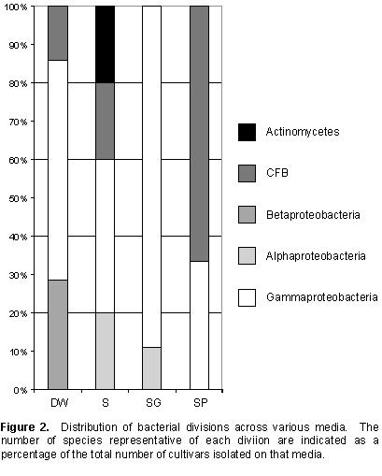

most starved, DW plates, contain representatives from the Clostridia/Firmacites/Bacillus Group as well as the Alpha- and Gammaproteobacteria, despite the lack of specific energy sources in this media. The agar plates that contained 5% soil extract demonstrated the highest levels of diversity when the media was not supplemented with 0.1% glycerol or the antioxidant 40 mM pyruvate, which can also serve as a carbon and energy source. It is interesting to note that the media which more closely resembles the chemistry found within the cave (S) demonstrates the highest diversity of cultivated species, rather than that containing the most available energy (SG).

In order to address how the role of trace metals and other nutrients affected the culturability of bacteria from Jack Bradley, we tested how the addition of supplements affected the diversity of species observed (Figure 3). As the
initial results suggested that, as the nutrient media more accurately reflects the nutritional environment within the cave leads to greater cultivar diversity, we attempted to use supplements that allow the media to better reflect the chemistry of the cave. To this end, we added 0.2% calcium carbonate (C) powder to a number of nutrient plates. We also assumed that there are a number trace minerals within the limestone rock itself, and that microbial species within this environment obtain trace vitamins from other species or from soil detritus percolating into the cave. To test the role of these essential elements on species isolation, we added Dulbecco’s defined vitamin (V) and mineral (M) supplement to our media. Last of all, we tested the role of a antioxidant against oxidative stress, which is thought to play a detrimental role in cultivation of oligotrophs (16). As an antioxidant, we added 40 mM pyruvate, although t should be noted that pyruvate also act as a weak carbon and energy source to many of the cultivars isolated (9). These supplements were added to the soil plates, which was the carbon and energy source that had demonstrated the greatest impact on species diversity during our previous cultivation experiment.
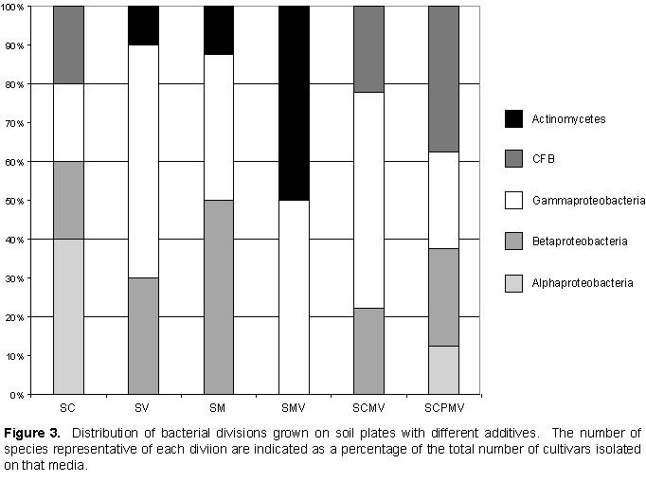

The results of the various additives on cultivar growth and diversity (Figure 3) demonstrated that there was no particular supplement that dramatically increased the relative species diversity among the soil media tested. Rather, the results suggest that each additive changes the structure of the bacterial species that can be isolated from the plate. Of the media tested, again it was the media that best reflected the basic chemical structure of the cave (SC) that produced the largest amount of diversity across the bacterial divisions. It is interesting to note that the addition of pyruvate does increase the diversity in the SCPMV plates, although it is not possible to determine the role of oxidative stress protection from the role this nutrient may play as a carbon source.

Finally, while we generated data that demonstrated the effectiveness of various media in isolating bacterial species from these cave environments, it did not demonstrate the numbers and types of organisms that could be comparatively isolated from each location. To this end, using 16S SSU-rDNA sequencing and BLAST alignment, we identified the numbers and types of bacteria that were identified at each location; of the 111 unique phylotypes that were identified, 81 were successfully sequenced to provide species data. We grouped any like-species together based on the sequence date to generate operational taxanomic units (OTUs) similarly to a non-cultivation based phylogenetic study. The results (Figure 4) were striking. Within the organic-rich, copiotrophic environment, we identified 24 OTUs that represented nine disparate genera within the bacteria; however, in our oligotrophic environment we identified 57 OTUs that represent 17 different genera.
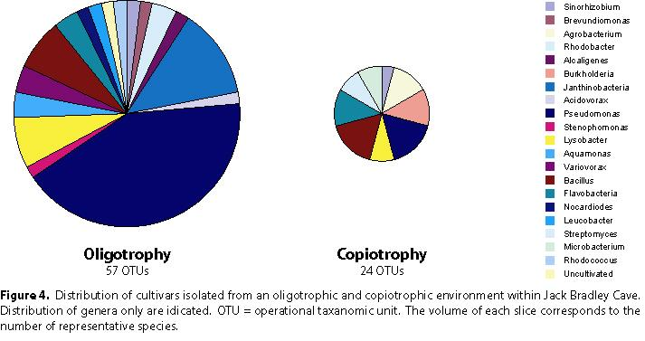

DISCUSSION

It was the aim of this work to determine whether the nutritional state of a cave environment plays any role in the type and culturability of bacterial species found within it. Our initial cultivation studies demonstrate that the type of media and additives used has a significant impact on the number of diversity of species isolated. Further, there appears to be an increase in the number of colony forming units as the carbon and energy sources in the plates become weaker. This would seem to be counter-intuitive, but is in accordance with other oligotrophic cultivation studies (18, 20). Nonetheless, the media that appear to most accurately reflect the actual conditions found within the particular cave environment being examined appears to allow the greatest diversity in the cultivated species identified.

It is interesting to note that soil extract appears to be necessary for the cultivation of Actinomycetes, which may be a critical component to the successful cultivation of these important soil organisms. Additionally, in plates where calcium carbonate has been added, no representative species from the Actinomycetes are identified. This may reflect an inability of these organisms to grow or produce colonies in the presence of this additive, although this would be unlikely as we have demonstrated that members of this genus are typically identified in carbonate-rich cave environments (3, 4, 7, 12, 14). This may also suggest why Actinomycetes have often been identified as the predominant species through cultivation from cave environments, as the growth media used classically lacks calcium carbonate (12, 14). Alternatively, the presence of high levels of calcium carbonate may also represent a previously unconsidered component to the cultivation of species from cave environments, such as the buffering capacity of carbonates during bacterial colony growth; the versatile Actinomycetes may be better adapted to acidification of the growth medium. While our results demonstrate important considerations for the cultivation of species from cave environments, they do not suggest an ‘ideal’ media for cultivation. It therefore remains important to use a number of different media conditions in order to acquire a diverse population of cultivated species.

Between the different environments, there was very little similarity in the types of species cultivated, with representatives from the Bacillus, Flavobacter, Lysobacter, Pseudomonas and Sniorhizobium shared between the two environments. This limited number of shared cultivars, and the type of species identified, may reflect the metabolic flexibility of many representative species within these genera. For example members of the Bacilli are able to make spores, allowing transition to high nutrient conditions, while species of Pseudomonas are adapted to survive the transition from extremely starved to nutrient replete conditions (9). Indeed, the metabolic flexibility of the Pseudomonads is reflected in the fact that members of this group (within the Gammaproteobacteria) were isolated in every type of medium used within this study. Such metabolic flexibility likely suggests why these species represent such a large number of the cultivated representatives from the oligotrophic environment, whereas they are rarely identified in non-cultivation studies from oligotrophic cave environments (3, 4, 7).

There were a significant number of species that were not shared between environments. Within the oligotrophic environment we identified members of the Rhodococcus, Rhodobacter and Nocardiodes, all of which demonstrate an ability to fix nitrogen gas. Such activity may be critically important within the context of a starved cave system, where nutrients such as nitrogen and phosphorous are limiting. In order to survive in such nutrient-limited conditions, it would be necessary for a microbial community to contain species that were able to fix many of these essential nutrients. Of the most predominant species identified within the oligotrophic environment, a large number of Janthinobacteria were identified, which are successful oligotrophs, able to scavenge an existence within extremely starved environments (9). The lack of these species within the copiotrophic environment may reflect an inability of this species to compete when there are more readily available energy sources for growth. Interestingly, within the copiotrophic environment are representatives from the Burkholderia that, while taxonomically related to the Janthinobacteria, are much better adapted to nutrient rich environments (9).

It was the aim of this study to take a comparative snap-shot of microbial activity within cave environments using cultivation. The results of our study support our hypothesis of increased microbial diversity within extremely starved environments, as well as significant metabolic differences between the species found there. Our results do suggest that within these starved environments it is essential that the growth media used represent, within all reasonable means, the actual chemical environment of the cave. In the future we aim to increase the number of culturable species within these environments by identifying and maintain syntrophic relationships that allow growth of previously non-culturable bacterial species within this environment.

ACKNOWLEDGEMENTS

The authors would like to thank Nicholas Taylor and Brad Lubbers for technical assistance in this project, Eric Weaver and Jason Gulley for caving assistance, and Mr. and Mrs. Jack Bradley Cave for allowing us to sample within their cave. This work was supported in part by grants from the Kentucky Academy of Science (USA) and the National Science Foundation (USA) EPSCoR Program to HAB. AP was supported by a SURG and travel grant from Northern Kentucky University and JM by the Merck/AAAS program.

REFERENCES

1. Achenbach, L. A., and J. D. Coates. 2000. Disparity between bacterial phylogeny and physiology. ASM News 66:714-715.
2. Amann, R. I., W. Ludwig, and K. H. Schleifer. 1995. Phylogenetic identification and in situ detection of individual microbial cells without cultivation. Microbiological Reviews 59:143-169.
3. Barton, H. A., M. R. Taylor, and N. R. Pace. 2004. Molecular Phylogenetic Analysis of a Bacterial Community in an Oligotrophic Cave Environment. J. Geomicrobiology 21:11-20.
4. Barton, H. A., N. M. Taylor, M. Kreate, and J. Bertog. 2005. The Impact of Organic Load on Geomicrobial Transformations in Subsurface Environments. Applied and Environmental Microbiology. In preparation.
5. Begon, M., J. L. Harper, and C. R. Townsend. 1998. Ecology: individuals, populations and communities. 3rd ed. Blackwell Scientific Publications., Cambridge, Mass.
6. Caumartin, V. 1963. Review of the microbiology of underground environments. Natl. Speleol. Soc. Bull. 25:1-14.
7. Chelius, M. K., and J. C. Moore. 2004. Molecular Phylogenetic Analysis of Archaea and Bacteria in Wind Cave, South Dakota. J. Geomicrobiology 21:123-134.
8. Cunningham, K. I., D. E. Northup, R. M. Pollastro, W. G. Wright, and E. J. LaRock. 1995. Bacteria, fungi and biokarst in Lechuguilla Cave, Carlsbad Caverns National Park, New Mexico. Environmental Geology 25:2-8.
9. Dworkin, M. 2002, posting date. The Prokaryotes: An evolving electronic resource for the microbiological community. Springer-Verlag, New York. [Online. http://link.springer-ny.com/link/service/books/10125]
10. Fry, J. C. 1990. Oligotrophs, p. 93-116. In C. Edwards (ed.), Microbiology of extreme environments. Open University Press, Milton Keynes.
11. Gottschal, J. C. 1993. Growth kinetics and competition -- some contempory comments. Ant. Leeuwenhoek 63:299-313.
12. Groth, I., and C. Saiz-Jimenez. 1999. Actinomycetes in Hypogean Environments. J. Geomicrobiology 16:1-8.
13. Groth, I., P. Schumann, L. Laiz, S. Moral-Sanchez, J. C. Canaveras, and C. Saiz-Jimenez. 2001. Geomicrobiological study of the Grotta dei Cervi, Porto Badisco, Italy. J. Geomicrobiology 18:241-258.
14. Groth, I., R. Vettermann, B. Schuetze, P. Schumann, and C. Saiz-Jimenez. 1999. Actinomycetes in Karstic caves of Northern Spain (Altamira and Tito Bustillo). J. Microbiol. Methods. 36:115-122.
15. Klimchouk, A. B., D. C. Ford, A. N. Palmer, and W. Dreybrodt. 2000. Speleogenesis: Evolution of Karstic Aquifers. National Speleological Society, Huntsville, AL.
16. Koch, A. L. 1997. Microbial physiology and ecology of slow growth. Microbiology and Molecular Biology Reviews 61:305-318.
17. Koch, A. L. 2001. Oligotrophs versus copiotrophs. BioEssays 23:657-661.
18. Kuznetsov, S. I., G. A. Dubinina, and N. A. Lapteva. 1979. Biology of Oligotrophic Bacteria. Annual Review Microbiology 33:377-87.
19. Peck, S. B. 1986. Bacterial deposition of iron and manganese oxides in North American caves. Natl. Speleol. Soc. Bull. 48:26-30.
20. Poindexter, J. S. 1981. Oligotrophy: Fast and Famine Existence. Advances Microbial Ecology 5:63-90.

